**MODULE : 1**

1. what is software? what is software engineering

what is software : system software provides the basic function for computer usage and helps run the computer hardware and system

what is software engineering : Software engineering is the branch of computer science that deals with the design, development, testing, and maintenance of software application. Software engineering apply engineering principles and knowledges of programming languages to build software solution for end users.

2. Explain types of software

Three types of software = 1. System software

2.Programming software

3.Application Software

1. System software: system software provides the basic functions for computer usage and helps run the computer hardware and system.

2. Programming software: programming is the process of designing, writing, testing, debugging, and maintaining the source code of computer programming. This source code is written in a programming language. The purpose of programming is the to create a program that exhibits a certain desired behavior.

1. Application Software: Application software is the general designation of computer programs for preforming user tasks.

3.What is SDLC? Explain each phase for SDLC.

The Software Development life cycle (SDLC) refers to a methodology with clearly defined processes for creating high-quality software.

SDLC methodology :

The software development life cycle (SDLC) refers to a methodology with clearly defined processes for creating high-quality software.in detail, the SDLC methodology focuses on the following phases of software development:

1. Requirement Gathering
2. Analysis
3. Designing
4. Implementation
5. Testing
6. maintenance

4.What is DFD? Create a DFD diagram on Flipkart

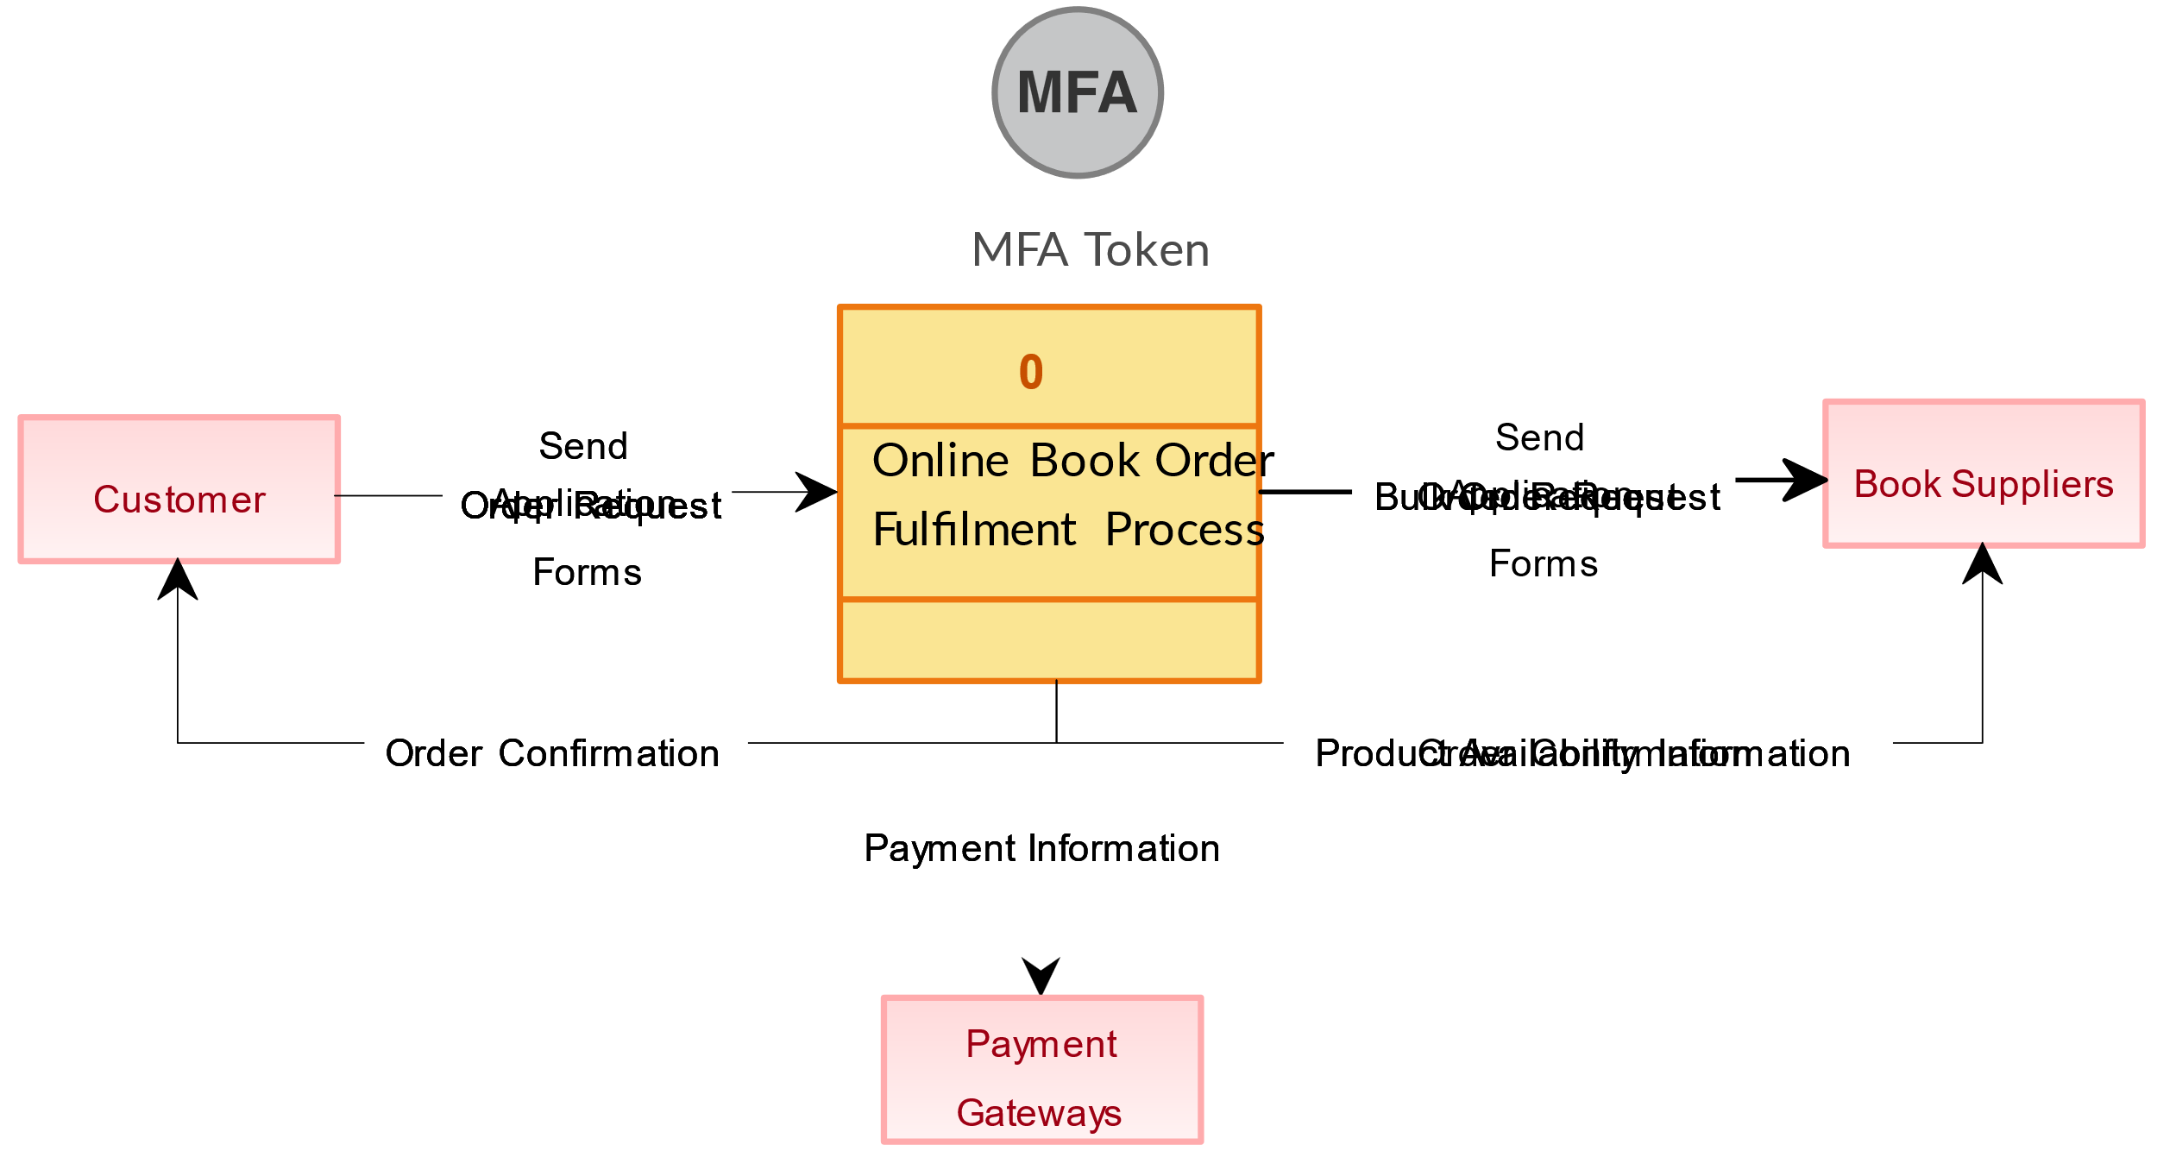

1. What is Flow chart? Create a flowchart to make addition of two numbers

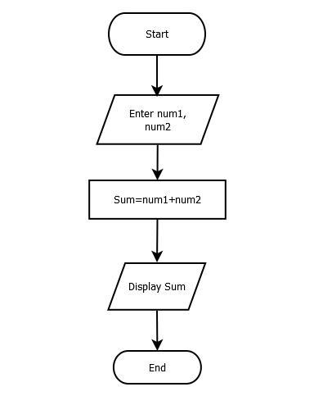

1. What is Use case Diagram? Create a use-case on bill payment on paytm.

